UECS3393 Software Entrepreneurship Tutorial 6

Tutorial 6 – Learning to Manage Innovation

- Consider the Seven Sources for Innovative Opportunities. That is

§§ Within the enterprise or industry
- Unexpected Occurrences
- Incongruities (i.e. incompatibilities)
- Process Needs
- Industry and Market Changes

§§ Outside the entreprise or industry
- Demographic Changes
- Perceptual Changes
- Knowledge-Based Concepts (both scientific and non-scientific)

Describe each source of innovation and provide ONE (1) example for each of them.


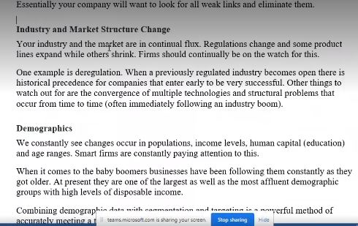Sources of Innovation: Need Pull § Complementary pull to the knowledge push - necessity as the mother of invention and innovation. § Innovations requires some form of demand if it is to take root. - Bright ideas are not enough, may not meet a real/perceived need & people may not feel motivated to change. - need to develop a clear understanding of needs and finding ways to meet those needs.

Sources of Innovation: Working at the Edge § Lies at the edges of existing markets. § Disruptive innovation is often associated with entrepreneurs working at the fringes of a mainstream market and finding groups whose need are not being met. - May creates different innovation options - Sometimes what has relevance for the fringe begins to be of interest to the mainstream.

Sources of Innovation: Emerging Markets § Considering the major growth in the world economy. § Contain large, young and increasingly affluent populations who are fuelling the demand for products and services and whose needs will increasingly shape the innovation agenda. - Their needs may be fundamentally different to those of the markets we have traditionally focused upon. - May represent a ‘fringe’ group

Sources of Innovation: Towards Mass Customization § The rise of a desire for customization § Powerful driver for innovation - Move from conditions where products are in short supply to one of mass production so demand for differentiation increases. § MC – the ability to offer highly configured bundles of non-price factors configured to suit different market segments.

- Differentiate between knowledge push innovations and need pull innovation.

Sources of Innovation: Knowledge Push § Creating opportunity by pushing the frontiers of science forward. § Emerge as a result of scientific research. § Growing field of automation & ICT technology came from organized R&D effort.

Sources of Innovation: Need Pull § Complementary pull to the knowledge push - necessity as the mother of invention and innovation. § Innovations requires some form of demand if it is to take root. - Bright ideas are not enough, may not meet a real/perceived need & people may not feel motivated to change. - need to develop a clear understanding of needs and finding ways to meet those needs.

- Describe ONE (1) example of knowledge push innovation and ONE (1) example of need pull innovation.

Knowledge push: create new drugs
Semiconductor, camera,NASA

Need Pull: Ford car, Air-asia, microfinance
- Describe an example of innovation that is considered as
- Invention innovation
Thomas edison light bulb
Floppy disk
Wright bros airplane
Alexandaer graham bell telephone
- Extension innovation
Desktop to laptop
Hd to portable hd
facebook
- Duplication innovation
Usb from floppy/hd
Database to cloud
Wal-mart?
- Synthesis innovation
Phone with camera
Phone with gps
Phone with cloud

